Test Case: tc001_SPX_Dev5_Crear_Requisicion_Spot_Tipo_Cobro_CC
Step 1 - Enter username and password and click to button Enter : Credentials Entered
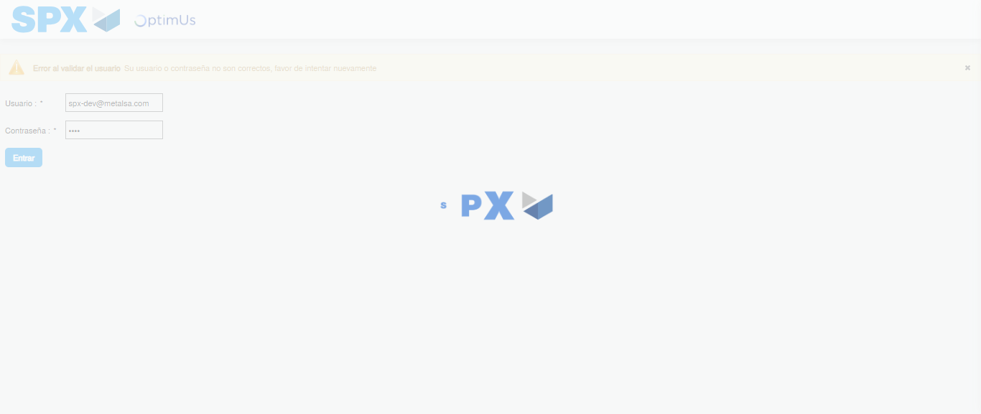Image file-name: QC_Testing-tc001_SPX_Dev5_Crear_Requisicion_Spot_Tipo_Cobro_CC-1783359257780

Step 2 - Select to UEN and Access to Spot Buy Requisitions : UEN Correctly selected and Correct access
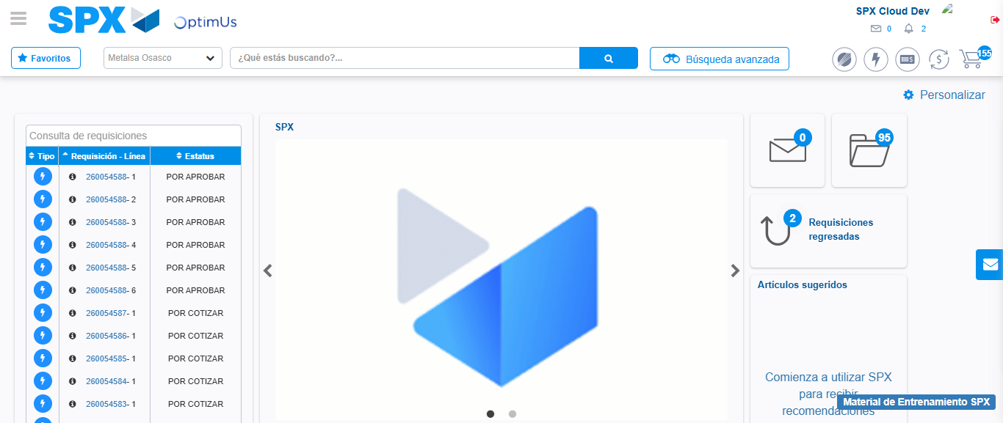Image file-name: QC_Testing-tc001_SPX_Dev5_Crear_Requisicion_Spot_Tipo_Cobro_CC-1783359283303

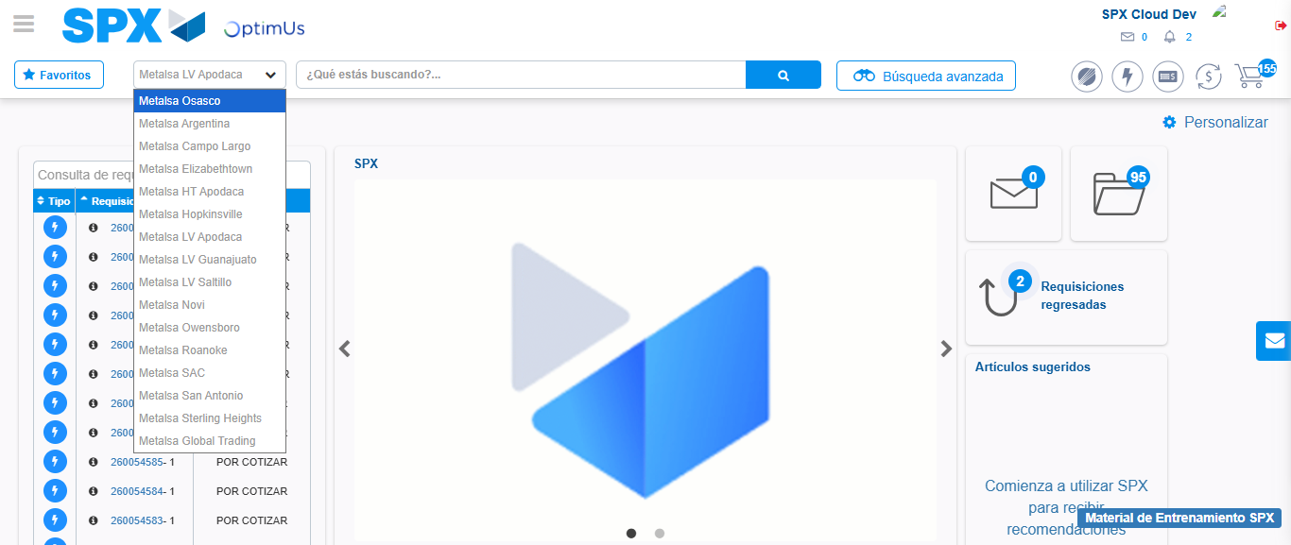Image file-name: QC_Testing-tc001_SPX_Dev5_Crear_Requisicion_Spot_Tipo_Cobro_CC-1783359286136

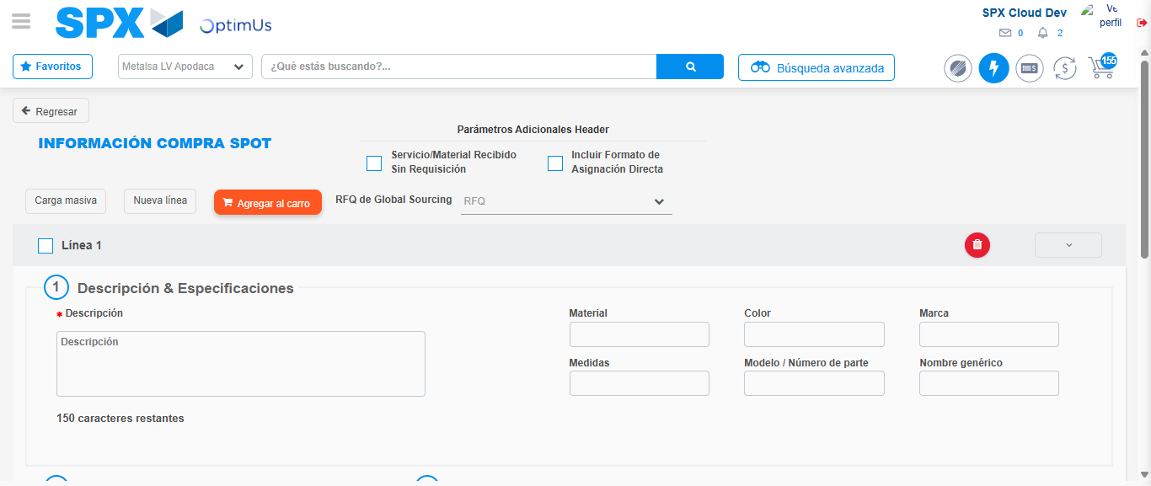Image file-name: QC_Testing-tc001_SPX_Dev5_Crear_Requisicion_Spot_Tipo_Cobro_CC-1783359308798

Step 3 - Data Capture Spot Buy Requisition : Data captured correctly
Image file-name: QC_Testing-tc001_SPX_Dev5_Crear_Requisicion_Spot_Tipo_Cobro_CC-1783359309087

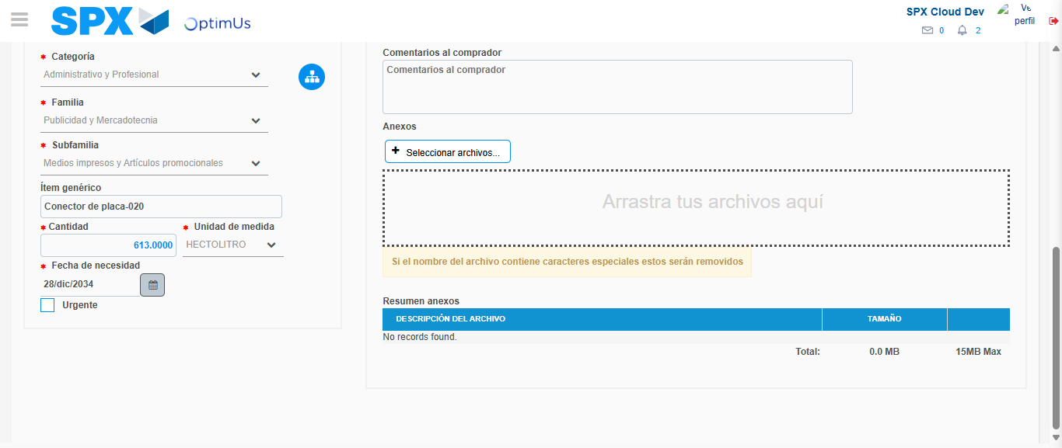Image file-name: QC_Testing-tc001_SPX_Dev5_Crear_Requisicion_Spot_Tipo_Cobro_CC-1783359321676

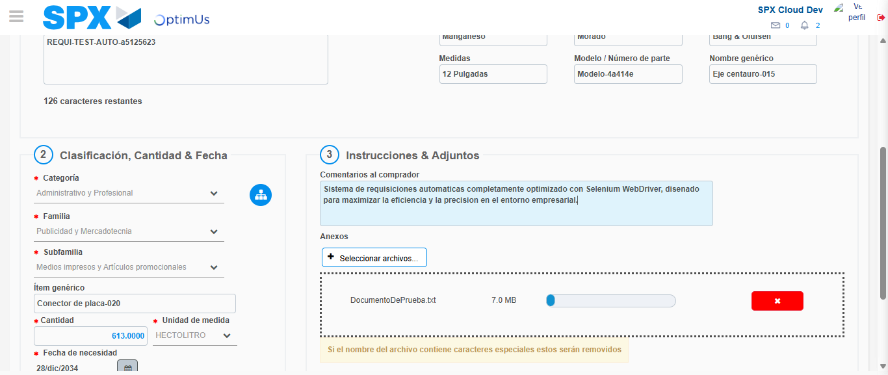Image file-name: QC_Testing-tc001_SPX_Dev5_Crear_Requisicion_Spot_Tipo_Cobro_CC-1783359322514

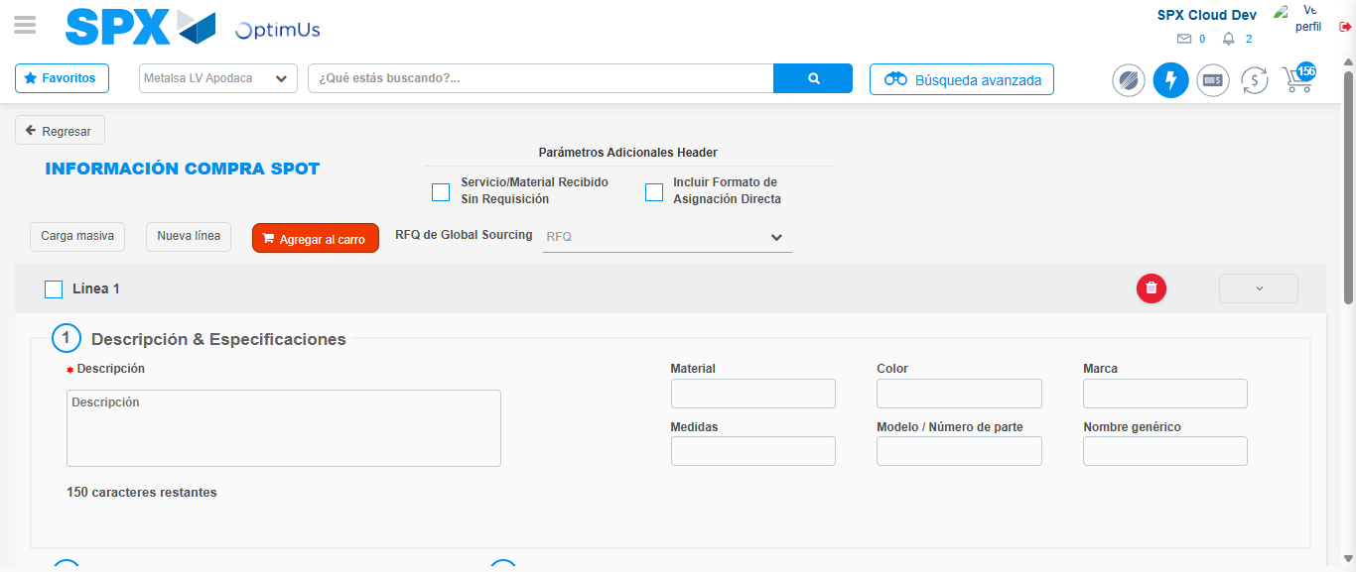Image file-name: QC_Testing-tc001_SPX_Dev5_Crear_Requisicion_Spot_Tipo_Cobro_CC-1783359335202

Step 7 - Return to Main Page SPX : Return to Main Page SPX
Image file-name: QC_Testing-tc001_SPX_Dev5_Crear_Requisicion_Spot_Tipo_Cobro_CC-1783359283303

Image file-name: QC_Testing-tc001_SPX_Dev5_Crear_Requisicion_Spot_Tipo_Cobro_CC-1783359286136

Image file-name: QC_Testing-tc001_SPX_Dev5_Crear_Requisicion_Spot_Tipo_Cobro_CC-1783359308798

Image file-name: QC_Testing-tc001_SPX_Dev5_Crear_Requisicion_Spot_Tipo_Cobro_CC-1783359337396

Image file-name: QC_Testing-tc001_SPX_Dev5_Crear_Requisicion_Spot_Tipo_Cobro_CC-1783359337530

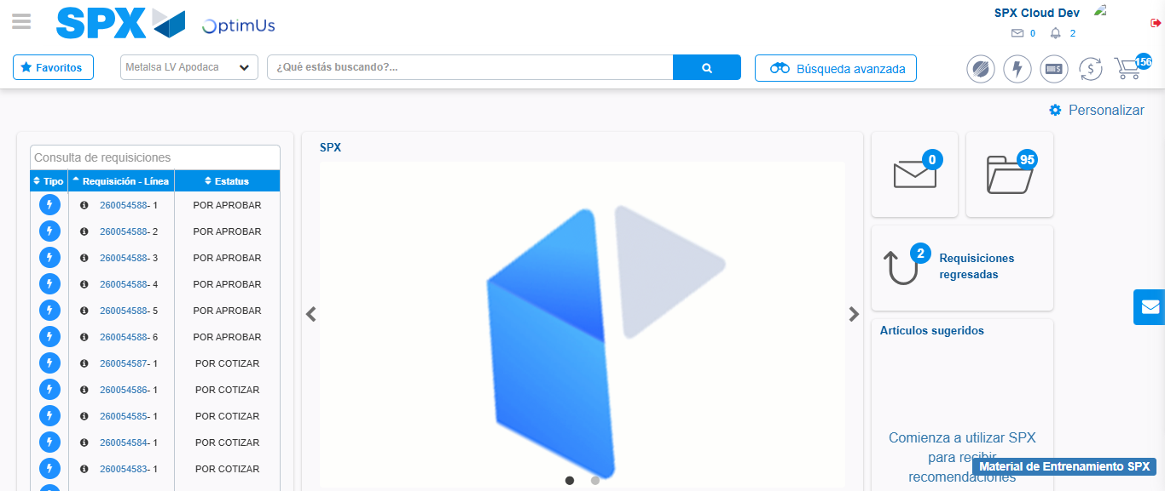Image file-name: QC_Testing-tc001_SPX_Dev5_Crear_Requisicion_Spot_Tipo_Cobro_CC-1783359358693

Step 8 - Log Out : Log Out SPX
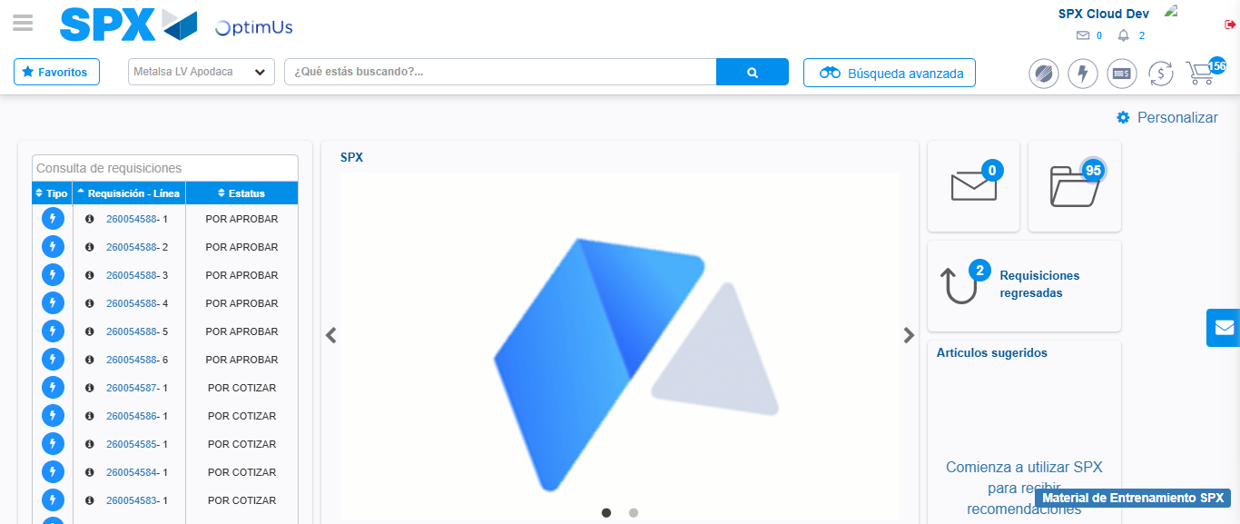Image file-name: QC_Testing-tc001_SPX_Dev5_Crear_Requisicion_Spot_Tipo_Cobro_CC-1783359358963

